Feb 2017 Work Package

1. Call Sheet “Call Information” change

When any of checkboxes of “Expected Time On Location” or “Will Call Back” is checked, the whole section of “Call Information (Call Out)” should be disabled and “Call Date/Time” and “Requested Date/Time” should be reset as DateTime.MinValue.

When the section of “Call Information (Call Out)” is enabled and “Call Date/Time” and “Requested Date/Time” should be reset as DateTime.Now.

Bug: When “Call Information (Call Out)” should be disabled, “Call Date/Time” and “Requested Date/Time” value are not reset.

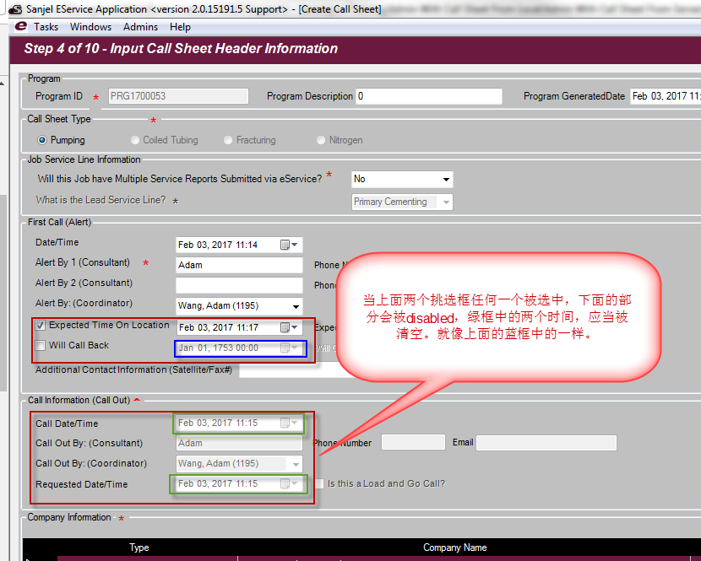

1. Import Well Information from “Wellbore Import” to “Well Specifics” page and “Well Hardware” Page

Import mapping refers to “Copy of Master Template 2.0.8 - eService Import - Wellbore instruction.xlsx” file

Formation section mapping refers to “Copy of Sufface and Production V3.0_170112 - Formation instruction.xlsx” file

Well Information Page UI mock refers to “WeeInformationPageMock.png”

Well Specifics page UI mock refers to “WellSpecificsPageMock.png”

Well Hardware page UI mock refers to “WellHardwarePageMock.png”

Other instructions:

1. Job Type section on the top of each page, it is only for reference, dropdown box should be disabled, current job type should be displayed.
2. Well Type mandatory sign and validation logic should be removed for Program.
3. Has Customer Experienced Losses mandatory sign and validation logic should be removed for Program.
4. Add entities to program.
5. Implement UI, Service, DAO, and database change as needed.
6. Add Formation sections to Call Sheet.
   1. There was no Formation section in Call Sheet. Add new properties added in CallSheetHeaderWellInformation.cs.
   2. Add Formation Section UI to Call Sheet Well Information Page
   3. Update service, DAO and database changes as needed.
   4. Update export call sheet, import call sheet if needed.
7. Update Create Call Sheet from Program use case. Carry over all imported well information to proper section in Call Sheet based on Job Type they are under.
8. Update Create Job Package from Call Sheet use case. Carry over all imported well information to proper section in Job/Service Report, except “Gas/Fluid Requirements”.
9. Fix Print Price Book Bug.

Attention: There are couple copies of configuration files in different project. If there is any conflict. The copy under CommonLibrary/SanjelPrintingService is final copy.

Printing Steps:

1. Find “Print Price Book” from Menu

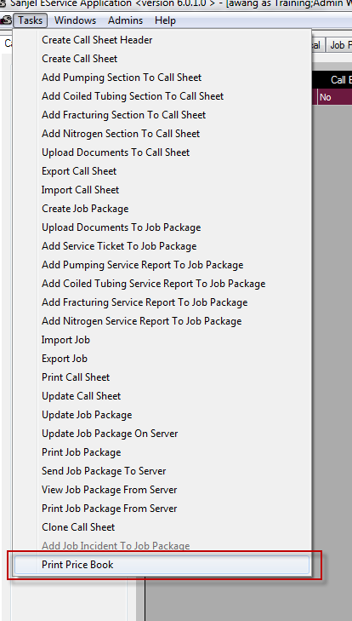

1. Click “Next” in “Step 1 of 2 – Select Price Book” screen
2. Check-off item 1006 and 1007.

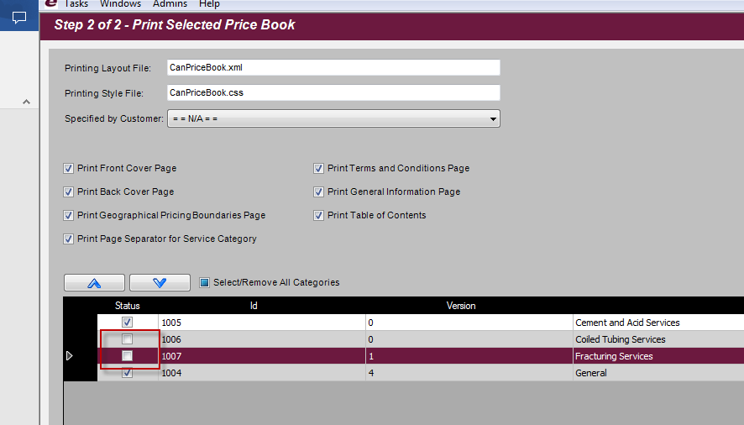

1. Look at the PDF file printed, there are some places like following image. This is the bug.

